

**KARATINA UNIVERSITY**

**SCHOOL OF PURE AND APPLIED SCIENCES**

**DEPARTMENT OF COMPUTER SCIENCE AND INFORMATICS**

**PROJECT TITLE: FAKE NEWS DETECTION AI SYSTEM**

**BY: ERIC LUMUMBA**

**REGISTRATION NUMBER: P101/1797G/21**

**DATE: 25TH FEBRUARY 2025**

This project is submitted in partial fulfilment of requirement for the Karatina University award of BACHELOR OF SCIENCE IN COMPUTER SCIENCE.

**DECLARATION**

I hereby declare that this project report is based on my original work except for citations and quotations which have been duly acknowledged. I also declare that it has not been previously and concurrently submitted for any other degree or award at Karatina University.

Signature:

Name:

ID No.:

Date:

**SUPERVISOR**

I the undersigned do hereby certify that this is a true report for the project undertaken by the above named student under my supervision and that it has been submitted to Karatina University with my approval.

Signature…………………………………………………….Date…………………………….

**DEDICATION**

Specially dedicated to

my esteemed lecturers for their invaluable guidance and support, to my fellow students for the shared experiences and collaboration, and to my parents and family for their unwavering encouragement and love throughout my academic journey.

**ACKNOWLEDGEMENT**

I would like to thank everyone who had contributed to the successful completion of this project. I would like to express my gratitude to my research supervisor, Mr. Thomas Njoroge, for his invaluable advice, guidance and his enormous patience throughout the development of the research. In addition, I would also like to express my gratitude to my loving parent and friends who had helped and given me encouragement and support throughout my academic journey.

**ABSTRACT**

The proliferation of fake news has become a significant challenge in the digital age, undermining public trust, influencing opinions, and disrupting societal harmony. To address this issue, we propose the development of an advanced Fake News Detection AI System that leverages cutting-edge natural language processing (NLP) and machine learning (ML) techniques. This system will analyze textual content, metadata, and source credibility to identify and flag potentially false or misleading information in real-time. By integrating multimodal data analysis, including text, images, and social media context, the system will provide a robust and scalable solution for detecting fake news across various platforms. The proposed AI system will be trained on diverse datasets, incorporating linguistic patterns, fact-checking databases, and user behavior analytics to improve accuracy and adaptability. Additionally, the system will feature an intuitive user interface for seamless integration into news platforms, social media, and fact-checking organizations. The ultimate goal of this project is to empower users, journalists, and policymakers with a reliable tool to combat misinformation, promote media literacy, and foster a more informed and resilient society. This proposal outlines the technical architecture, ethical considerations, and potential impact of the Fake News Detection AI System, positioning it as a critical step toward mitigating the global fake news epidemic.

**TABLE OF CONTENT**

COVER PAGE**I**

DECLARATION PAGEII

ABSTRACTIII

CHAPTER 14

INTRODUCTION4

1.1 Background of the Study and Problem Statement4

1.2 Objectives of the Project and Proposed Solution 5

1.3 Significance and Scope of the Study6

1.4 Assumptions and Limitations7

1.5 Definition of Terms8

CHAPTER 29

LITERATURE REVIEW AND THEORETICAL FRAMEWORK9

2.1 Overview of Fake News and Its Impact9

2.2 Existing Solutions and Their Limitations11

2.3 Advances in AI and NLP for Misinformation Detection13

2.4 Theoretical Framework for the Proposed System15

CHAPTER 316

METHODOLOGY AND SYSTEM DESIGN17

3.1 System Architecture and Workflow18

3.2 Data Collection and Preprocessing and Integration20

3.3 Machine Learning and NLP Techniques22

3.4 Model Training, Validation and Scalability24

CHAPTER 427

CHAPTER 4: IMPLEMENTATION PLAN AND EXPECTED OUTCOMES27

4.1Development Phases and Timeline27

4.2 Resource Allocation and Risk Management 29

4.3 Expected Outcomes and Impact31

4.4 Potential Applications and Future Work33

REFERENCES34

APPENDICES35

**LIST OF ABBREVIATIONS**

**LIST OF TABLES**

**LIST OF FIGURES**

**CHAPTER 1**

**INTRODUCTION**

**1.1 Background of the Study and Problem Statement**

In the digital age, the rapid proliferation of information through online platforms has revolutionized how people consume news. However, this convenience has also given rise to the spread of **fake news**, which refers to deliberately fabricated or misleading information presented as factual news. Fake news has become a global concern, influencing public opinion, disrupting democratic processes, and even inciting violence in extreme cases. The 2016 U.S. presidential election and the COVID-19 pandemic are notable examples where fake news significantly impacted societal behavior and decision-making (Allcott & Gentzkow, 2017).

The rise of social media platforms, such as Facebook, Twitter, and WhatsApp, has exacerbated the problem by enabling the rapid dissemination of unverified information. Unlike traditional media, these platforms lack stringent editorial controls, making it easier for malicious actors to spread misinformation. According to a 2018 study by the Massachusetts Institute of Technology (MIT), false news stories are 70% more likely to be shared than true stories, highlighting the viral nature of misinformation (Shu et al., 2017).

Despite efforts by tech companies and governments to combat fake news, existing solutions have proven inadequate. Manual fact-checking, while effective, is time-consuming and cannot scale to match the volume of information generated daily. Automated tools, on the other hand, often lack the sophistication to accurately distinguish between credible and fake news, especially when dealing with nuanced language or context-specific content (Zhou & Zafarani, 2020).

This study seeks to address the growing challenge of fake news by developing an **AI-based fake news detection system**. The proposed system will leverage advancements in **Natural Language Processing (NLP)** and **Machine Learning (ML)** to automatically analyze and classify news articles as either credible or fake. By doing so, the system aims to provide a scalable, efficient, and accurate solution to the problem of misinformation.

**1.2 Objectives of the Project and Proposed Solution**

The primary goal of this project is to design and implement an **AI-based fake news detection system** that can effectively identify and classify misinformation in online news articles. To achieve this, the project is guided by the following specific objectives:

1. **To analyze the characteristics of fake news**: The project will investigate the linguistic, structural, and contextual features that distinguish fake news from credible news. This analysis will form the foundation for developing an accurate detection model (Wang, 2017).
2. **To develop a robust dataset for training and testing**: A critical component of the project is the creation of a comprehensive dataset comprising both fake and credible news articles. This dataset will be curated from diverse sources, including social media platforms, news websites, and fact-checking organizations, to ensure its relevance and reliability (Shu et al., 2017).
3. **To design and implement machine learning and NLP models**: The project will explore and implement state-of-the-art machine learning and natural language processing techniques, such as **deep learning**, **sentiment analysis**, and **text classification**, to build a model capable of detecting fake news with high accuracy (Devlin et al., 2019).
4. **To evaluate the performance of the proposed system**: The system will be rigorously tested using standard evaluation metrics, such as **precision**, **recall**, **F1-score**, and **accuracy**, to assess its effectiveness in detecting fake news. The evaluation will also include a comparison with existing solutions to highlight the improvements offered by the proposed system (Zhou & Zafarani, 2020).
5. **To provide a user-friendly interface for the system**: The final output of the project will be a web-based or desktop application that allows users to input news articles and receive a classification result (fake or credible) in real-time. The interface will be designed to be intuitive and accessible to non-technical users.

**1.3 Significance and Scope of the Study**

The proliferation of fae news has far-reaching consequences for individuals, communities, and societies at large. Misinformation can distort public perception, influence political outcomes, and even endanger public health, as seen during the COVID-19 pandemic when false information about vaccines and treatments spread rapidly. This study is significant for the following reasons:

1. **Combating Misinformation**: The proposed AI-based fake news detection system provides a technological solution to the growing problem of misinformation. By automating the detection process, the system can help reduce the spread of fake news and promote the consumption of credible information (Allcott & Gentzkow, 2017).
2. **Enhancing Media Literacy**: The development of such a system raises awareness about the prevalence of fake news and encourages users to critically evaluate the information they encounter online. This contributes to improved media literacy and a more informed public (Shu et al., 2017).
3. **Supporting Fact-Checking Efforts**: While manual fact-checking remains essential, it is often time-consuming and resource-intensive. The proposed system can complement these efforts by providing an initial screening of news articles, allowing fact-checkers to focus on more complex cases (Zhou & Zafarani, 2020).
4. **Advancing AI and NLP Research**: This project contributes to the fields of artificial intelligence and natural language processing by exploring innovative techniques for text classification and misinformation detection. The insights gained from this study can inform future research and development in these areas (Devlin et al., 2019).
5. **Promoting Social Stability**: By curbing the spread of fake news, the system can help mitigate its negative societal impacts, such as political polarization, social unrest, and public panic. This promotes a more stable and harmonious society (Wang, 2017).

**1.4 Assumptions and Limitations**

This study is based on the following assumptions:

1. **Availability of Quality Data**: The project assumes the availability of a sufficiently large and diverse dataset of both fake and credible news articles for training and testing the AI models. The quality of the dataset is critical to the performance of the system (Shu et al., 2017).
2. **Relevance of Linguistic Features**: The study assumes that linguistic and contextual features, such as word choice, sentence structure, and sentiment, are reliable indicators of fake news. These features form the basis for the machine learning models used in the system (Devlin et al., 2019).
3. **Generalizability of Models**: It is assumed that the machine learning models developed in this study will generalize well to new, unseen news articles, provided they are trained on a representative dataset (Zhou & Zafarani, 2020).
4. **User Cooperation**: The project assumes that users will provide accurate feedback on the system’s classification results, which will be used to improve the model over time.
5. **Ethical Use of the System**: The study assumes that the proposed system will be used ethically and responsibly, without malicious intent or bias (Allcott & Gentzkow, 2017).

**1.5 Definition of Terms**

To ensure clarity and consistency, the following key terms used in this study are defined:

1. **Fake News**: Deliberately fabricated or misleading information presented as factual news, often with the intent to deceive or manipulate readers (Allcott & Gentzkow, 2017).
2. **Natural Language Processing (NLP)**: A subfield of artificial intelligence that focuses on the interaction between computers and human language, enabling machines to understand, interpret, and generate text (Devlin et al., 2019).
3. **Machine Learning (ML)**: A branch of artificial intelligence that involves training algorithms to learn patterns from data and make predictions or decisions without explicit programming (Goodfellow et al., 2016).
4. **Text Classification**: A process in NLP where text documents are automatically categorized into predefined classes or labels, such as "fake" or "credible" (Zhou & Zafarani, 2020).
5. **Dataset**: A collection of data used for training and evaluating machine learning models. In this study, the dataset consists of labeled news articles (Shu et al., 2017).

**CHAPTER 2**

**LITERATURE REVIEW AND THEORETICAL FRAMEWORK**

**2.1 Overview of Fake News and Its Impact**

Fake news has become a pervasive issue in the digital age, with its origins tracing back to the early days of mass communication. Historically, fake news was often used as a tool for propaganda, with governments and organizations disseminating false information to influence public opinion. However, the advent of the internet and social media has exponentially increased the speed and scale at which fake news can spread, making it a global concern (Allcott & Gentzkow, 2017).

The term "fake news" refers to intentionally fabricated or misleading information presented as factual news. It is often created to deceive readers, promote a particular agenda, or generate financial gain through clickbait. Fake news can take various forms, including entirely fabricated stories, manipulated images or videos, and misleading headlines designed to distort the truth (Shu et al., 2017).

The impact of fake news is far-reaching and multifaceted. Some of the key consequences include:

1. **Political Polarization**: Fake news has been used to manipulate public opinion and influence political outcomes. For example, during the 2016 U.S. presidential election, fake news stories were widely shared on social media, contributing to increased polarization and mistrust in democratic institutions (Allcott & Gentzkow, 2017).
2. **Public Health Risks**: The spread of misinformation during the COVID-19 pandemic highlighted the dangers of fake news in the context of public health. False claims about vaccines, treatments, and the origins of the virus led to confusion, vaccine hesitancy, and even harmful behaviors, such as the consumption of unproven remedies (Zhou & Zafarani, 2020).
3. **Social Unrest**: Fake news can incite fear, anger, and violence by spreading false information about individuals, groups, or events. For instance, rumors and misinformation have been linked to instances of mob violence and communal tensions in various parts of the world (Wang, 2017).
4. **Economic Consequences**: Businesses and economies can also suffer from the spread of fake news. False information about companies or financial markets can lead to stock price fluctuations, loss of consumer trust, and reputational damage (Shu et al., 2017).
5. **Erosion of Trust**: The proliferation of fake news undermines trust in traditional media, institutions, and even science. When people are exposed to conflicting information, they may become skeptical of all sources, making it difficult to distinguish between credible and fake news (Allcott & Gentzkow, 2017).

The widespread impact of fake news underscores the urgent need for effective solutions to combat its spread. While efforts have been made to address the issue, such as fact-checking initiatives and content moderation by social media platforms, these measures have proven insufficient in curbing the problem. This has led to increased interest in leveraging artificial intelligence and natural language processing to develop automated solutions for fake news detection (Zhou & Zafarani, 2020).

**2.2 Existing Solutions and Their Limitations**

Efforts to combat fake news have taken various forms, ranging from manual fact-checking to automated tools powered by artificial intelligence. While these solutions have made some progress, they are not without limitations. This section provides an overview of existing approaches and their challenges (Shu et al., 2017).

**Manual Fact-Checking**

Manual fact-checking involves human experts verifying the accuracy of news stories by cross-referencing information with credible sources. Organizations like **Snopes**, **FactCheck.org**, and **PolitiFact** have been at the forefront of this effort.

* **Strengths**:
  + High accuracy due to human judgment and contextual understanding.
  + Ability to handle nuanced or complex cases that automated systems may miss.
* **Limitations**:
  + Time-consuming and labor-intensive, making it difficult to scale to the volume of information generated daily.
  + Limited coverage, as fact-checkers can only address a small fraction of the misinformation circulating online (Allcott & Gentzkow, 2017).

**Social Media Platform Policies**

Social media platforms like Facebook, Twitter, and YouTube have implemented policies to curb the spread of fake news. These include flagging misleading content, reducing the visibility of suspicious posts, and partnering with fact-checking organizations.

* **Strengths**:
  + Wide reach, as these platforms are primary channels for the dissemination of fake news.
  + Ability to quickly remove or flag harmful content.
* **Limitations**:
  + Inconsistent enforcement of policies, leading to accusations of bias or censorship.
  + Difficulty in keeping up with the sheer volume of content posted daily.
  + Limited effectiveness in addressing misinformation shared through private messaging apps like WhatsApp (Zhou & Zafarani, 2020).

**Automated Detection Tools**

Automated tools leverage machine learning and natural language processing to detect fake news. These systems analyze textual features, such as language patterns, sentiment, and source credibility, to classify news articles.

* **Strengths**:
  + Scalability, as they can process large volumes of data in real-time.
  + Potential for high accuracy when trained on robust datasets.
* **Limitations**:
  + Dependence on the quality and diversity of training data, which can introduce biases.
  + Difficulty in detecting sophisticated fake news that mimics credible content.
  + Limited ability to interpret context or sarcasm, leading to false positives or negatives (Shu et al., 2017).

**Crowdsourced Fact-Checking**

Platforms like **Wikipedia** and **Google’s Fact Check Explorer** rely on crowdsourcing to verify information. Users contribute to identifying and correcting misinformation.

* **Strengths**:
  + Leverages the collective intelligence of a large user base.
  + Rapid response to emerging misinformation.
* **Limitations**:
  + Vulnerable to manipulation or bias from contributors.
  + Lack of consistency in the quality of fact-checking (Allcott & Gentzkow, 2017).

In summary, while existing solutions have made strides in addressing fake news, their limitations highlight the need for more advanced, scalable, and accurate approaches. This has led to increased interest in leveraging cutting-edge AI and NLP techniques, as discussed in the next section.

**2.3 Advances in AI and NLP for Misinformation Detection**

Recent advancements in artificial intelligence (AI) and natural language processing (NLP) have opened new possibilities for detecting and combating fake news. These technologies offer the potential to overcome many of the limitations of existing solutions by automating the analysis of textual content and identifying patterns indicative of misinformation. This section explores key developments in AI and NLP that are relevant to fake news detection (Devlin et al., 2019).

**Deep Learning Models**

Deep learning, a subset of machine learning, has revolutionized text analysis by enabling models to learn complex patterns from large datasets. Techniques such as **Recurrent Neural Networks (RNNs)** and **Convolutional Neural Networks (CNNs)** have been applied to fake news detection with promising results.

* **RNNs**: These models are particularly effective for sequential data, such as text, as they can capture dependencies between words and phrases. Variants like **Long Short-Term Memory (LSTM)** and **Gated Recurrent Units (GRUs)** have been used to analyze the linguistic structure of news articles (Goodfellow et al., 2016).
* **CNNs**: Originally designed for image processing, CNNs have been adapted for text analysis by treating words or phrases as "features" in a spatial context. They are effective for identifying patterns in fixed-length text segments (Zhou & Zafarani, 2020).

**Transformer-Based Models**

Transformer-based models, such as **BERT (Bidirectional Encoder Representations from Transformers)** and **GPT (Generative Pre-trained Transformer)**, have set new benchmarks in NLP tasks. These models use self-attention mechanisms to capture contextual relationships between words, enabling them to understand the meaning of text more effectively.

* **BERT**: Pretrained on large corpora, BERT can be fine-tuned for specific tasks like fake news detection. Its bidirectional nature allows it to consider the context of words from both directions, improving accuracy (Devlin et al., 2019).
* **GPT**: While primarily used for text generation, GPT-based models can also be adapted for classification tasks by fine-tuning on labeled datasets (Vaswani et al., 2017).

**Sentiment and Stylometric Analysis**

Sentiment analysis involves assessing the emotional tone of text, which can be useful for identifying fake news. For example, sensational or overly negative language is often a hallmark of misinformation. Stylometric analysis, on the other hand, examines writing style, such as word choice and sentence structure, to detect inconsistencies or anomalies that may indicate fake news (Shu et al., 2017).

**Graph-Based Approaches**

Fake news often spreads through networks of users and sources. Graph-based approaches model these networks to identify patterns of misinformation dissemination. For example, analyzing the relationships between news sources, authors, and social media users can help identify clusters of fake news (Zhou & Zafarani, 2020).

**Multimodal Analysis**

While this study focuses on text-based fake news, advances in multimodal analysis allow for the integration of multiple data types, such as text, images, and videos. This is particularly relevant for detecting fake news that relies on manipulated visuals or multimedia content (Devlin et al., 2019).

**Challenges and Future Directions**

Despite these advancements, challenges remain. For instance, AI models require large, high-quality datasets for training, which can be difficult to obtain. Additionally, fake news creators are constantly evolving their tactics, requiring models to adapt quickly. Future research may focus on improving model interpretability, reducing biases, and integrating real-time feedback mechanisms (Zhou & Zafarani, 2020).

In conclusion, advances in AI and NLP offer powerful tools for detecting fake news. By leveraging these technologies, the proposed system aims to provide a more effective and scalable solution to the problem of misinformation.

**2.4 Theoretical Framework for the Proposed System**

The development of the proposed **AI-based fake news detection system** is grounded in a robust theoretical framework that integrates principles from **information theory**, **machine learning**, and **natural language processing (NLP)**. This framework provides the foundation for understanding how the system will analyze, classify, and detect fake news. The key components of the theoretical framework are outlined below.

**1. Information Theory and Misinformation**

Information theory, pioneered by Claude Shannon, provides a mathematical framework for understanding the transmission, processing, and storage of information. In the context of fake news, information theory helps explain how misinformation spreads and how it can be detected. Key concepts include:

* **Entropy**: A measure of uncertainty or randomness in information. Fake news often exhibits higher entropy due to its sensational or inconsistent nature.
* **Signal-to-Noise Ratio (SNR)**: The ratio of meaningful information (signal) to irrelevant or misleading information (noise). The proposed system aims to maximize SNR by filtering out fake news.

To illustrate the relationship between entropy and fake news, consider the following table:

**Table 2.1: Entropy Levels in Fake News vs. Credible News**

|  |  |  |
| --- | --- | --- |
| **News Type** | **Entropy Level** | **Description** |
| **Fake News** | High | Sensational language, inconsistent facts, and exaggerated claims increase entropy. |
| **Credible News** | Low | Clear, consistent, and well-supported information reduces entropy. |

**2. Machine Learning and Pattern Recognition**

Machine learning forms the core of the proposed system, enabling it to learn patterns from data and make predictions. The theoretical underpinnings of machine learning include:

* **Supervised Learning**: The system will use labeled datasets (fake vs. credible news) to train models that can classify new articles. Algorithms such as **Support Vector Machines (SVM)**, **Random Forests**, and **Neural Networks** will be explored.
* **Feature Extraction**: The system will identify relevant features, such as word frequency, sentiment, and syntactic patterns, that distinguish fake news from credible news.
* **Model Evaluation**: Metrics like **precision**, **recall**, **F1-score**, and **accuracy** will be used to assess the performance of the models.

The following figure illustrates the workflow of the machine learning process:

**Figure 2.1: Machine Learning Workflow for Fake News Detection:**

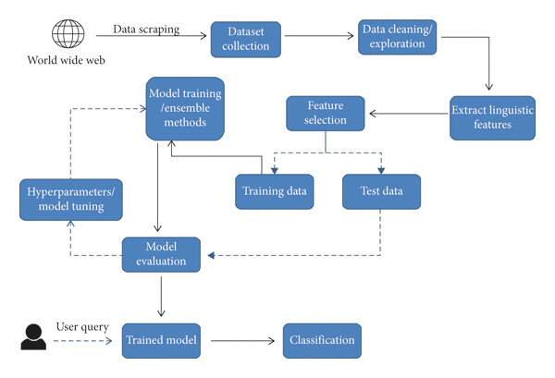

**3. Natural Language Processing (NLP)**

NLP provides the tools and techniques for analyzing and understanding human language. The proposed system will leverage the following NLP concepts:

* **Tokenization**: Breaking down text into individual words or phrases for analysis.
* **Named Entity Recognition (NER)**: Identifying and classifying entities (e.g., people, organizations, locations) in text, which can help verify the credibility of news articles.
* **Sentiment Analysis**: Assessing the emotional tone of text to identify sensational or biased language often associated with fake news.
* **Semantic Analysis**: Understanding the meaning and context of words and phrases to detect inconsistencies or misleading information.

The following table summarizes the NLP techniques used in the system:

**Table 2.2: NLP Techniques for Fake News Detection**

|  |  |  |
| --- | --- | --- |
| **Technique** | **Description** | **Application in Fake News Detection** |
| **Tokenization** | Splitting text into individual words or phrases. | Preprocessing step to prepare text for analysis. |
| **Named Entity Recognition (NER)** | Identifying and classifying entities (e.g., people, organizations). | Verifying the credibility of sources and claims. |
| **Sentiment Analysis** | Assessing the emotional tone of text. | Detecting sensational or biased language. |
| **Semantic Analysis** | Understanding the meaning and context of words and phrases. | Identifying inconsistencies or misleading information. |

**4. Network Theory and Dissemination Patterns**

Fake news often spreads through networks of users and sources. Network theory provides insights into how information propagates and how fake news can be identified based on dissemination patterns. Key concepts include:

* **Graph Theory**: Modeling the relationships between news sources, authors, and social media users as a graph to identify clusters or hubs of misinformation.
* **Centrality Measures**: Identifying influential nodes (e.g., popular users or websites) that play a key role in spreading fake news.

The following figure illustrates a network graph of fake news dissemination:

**Figure 2.2: Network Graph of Fake News Dissemination**

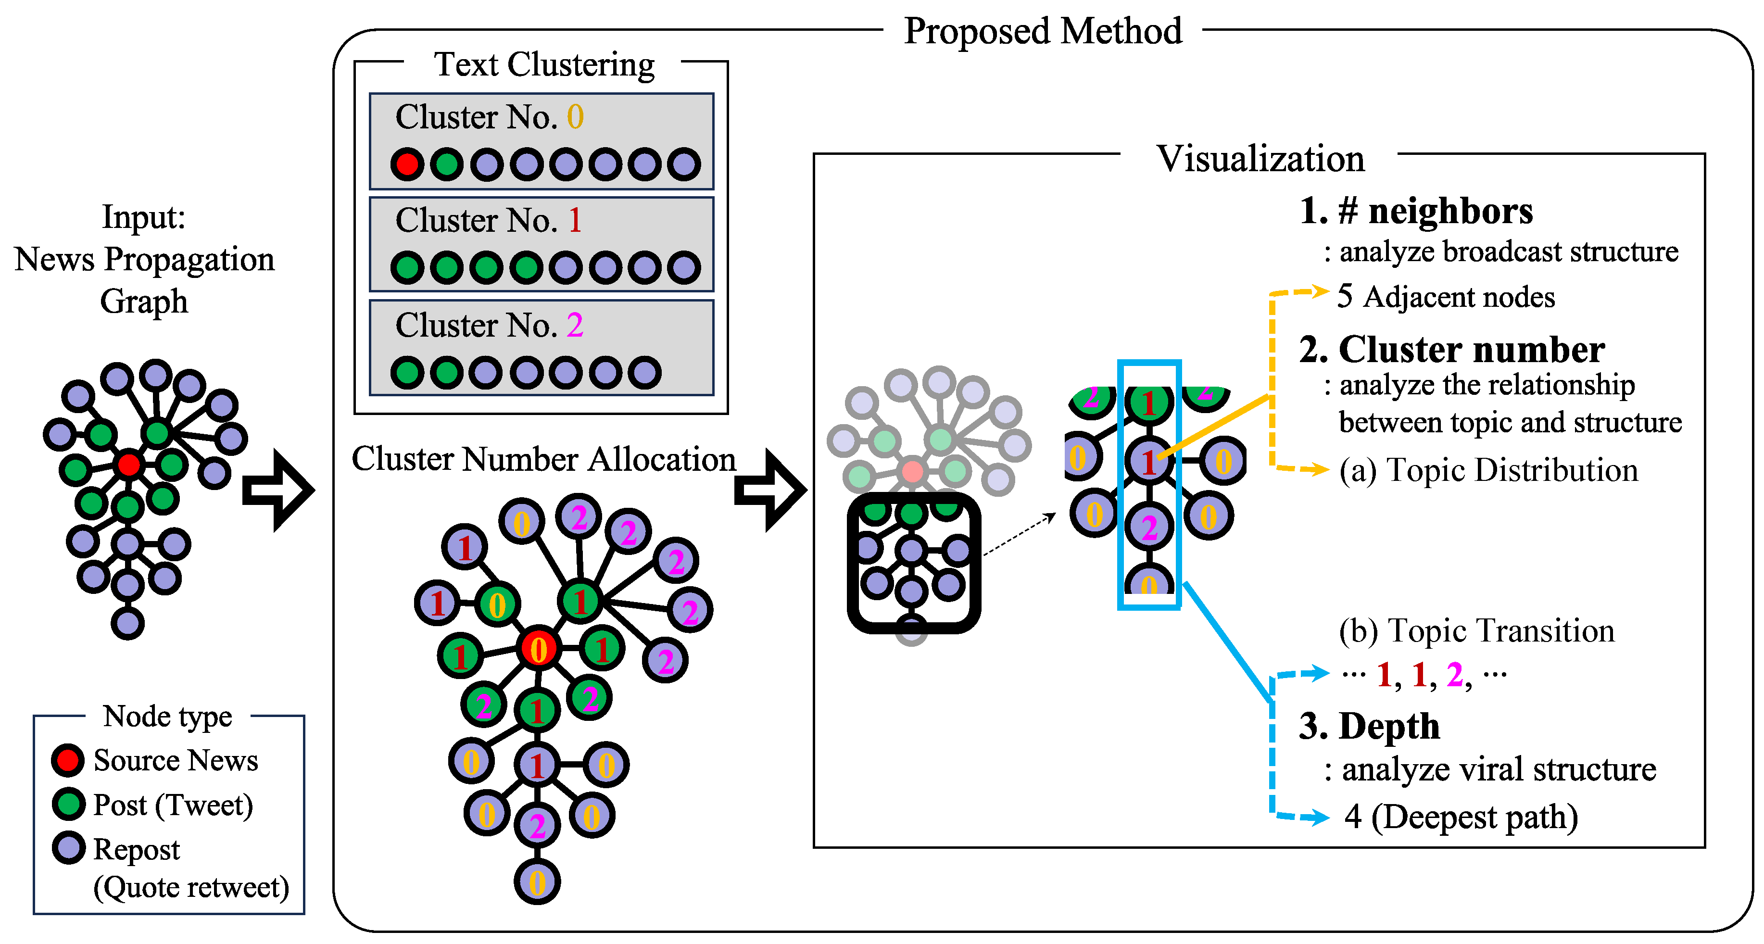

**5. Human-Computer Interaction (HCI)**

The proposed system will include a user-friendly interface to facilitate interaction between users and the AI model. HCI principles will guide the design of the interface, ensuring it is intuitive, accessible, and effective in presenting classification results.

**6. Ethical and Societal Considerations**

The theoretical framework also incorporates ethical principles to ensure the system is used responsibly. This includes addressing potential biases in the training data, ensuring transparency in the decision-making process, and safeguarding user privacy.

**Integration of Theoretical Components**

The proposed system integrates these theoretical components into a cohesive framework. For example:

* Information theory guides the identification of high-entropy features in fake news.
* Machine learning and NLP techniques enable the system to analyze and classify text.
* Network theory helps identify patterns of misinformation dissemination.
* HCI principles ensure the system is user-friendly and accessible.

By grounding the system in this theoretical framework, the proposed solution aims to provide a robust, accurate, and scalable tool for detecting fake news, contributing to a more informed and resilient society.

**CHAPTER 3**

**METHODOLOGY AND SYSTEM DESIGN**

**3.1 System Architecture and Workflow**

The proposed **AI-based fake news detection system** is designed as a modular and scalable solution that integrates data collection, preprocessing, machine learning, and user interaction. The system architecture is divided into four main components, each serving a specific function in the workflow. Below is an overview of the system architecture and its workflow.

**System Architecture**

1. **Data Collection Module**:
   * This module is responsible for gathering news articles from various sources, including social media platforms, news websites, and fact-checking databases.
   * APIs (Application Programming Interfaces) and web scraping tools will be used to collect data in real-time or from archived datasets.
2. **Preprocessing and Integration Module**:
   * The raw data collected is cleaned and transformed into a format suitable for analysis. This includes:
     + **Tokenization**: Breaking text into individual words or phrases.
     + **Stopword Removal**: Eliminating common words (e.g., "the," "and") that do not contribute to the meaning.
     + **Stemming/Lemmatization**: Reducing words to their base or root form.
     + **Feature Extraction**: Identifying relevant features such as word frequency, sentiment, and named entities.
3. **Machine Learning and NLP Module**:
   * This module is the core of the system, where machine learning and NLP techniques are applied to classify news articles as fake or credible.
   * Techniques such as **deep learning**, **sentiment analysis**, and **text classification** will be used to build and train the models.
4. **User Interface Module**:
   * A user-friendly interface will allow users to input news articles and receive classification results in real-time.
   * The interface will display the results along with confidence scores and explanations for the classification.

**System Workflow**

1. **Data Ingestion**:
   * News articles are collected from various sources and stored in a centralized database.
2. **Preprocessing**:
   * The collected data is cleaned and transformed into a structured format. Feature extraction is performed to identify relevant attributes for analysis.
3. **Model Training**:
   * The preprocessed data is split into training and testing datasets. Machine learning models are trained using the training dataset and validated using the testing dataset.
4. **Real-Time Classification**:
   * Once trained, the model is deployed to classify new news articles in real-time. Users can input articles through the interface and receive instant results.
5. **Feedback and Improvement**:
   * Users can provide feedback on the classification results, which will be used to retrain and improve the model over time.

**Visual Representation of the Workflow**

The following figure illustrates the system workflow:

**Figure 3.1: System Workflow for Fake News Detection**

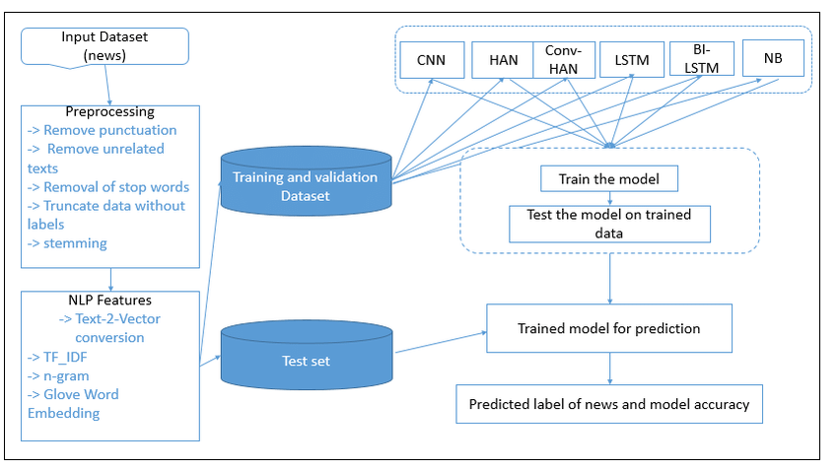

**3.2 Data Collection and Preprocessing**

The success of the proposed system heavily depends on the quality and diversity of the data used for training and testing. This section outlines the methodologies for data collection and preprocessing.

**Data Collection**

1. **Sources of Data**:
   * **Social Media Platforms**: Data will be collected from platforms like Twitter, Facebook, and Reddit, where fake news is frequently disseminated.
   * **News Websites**: Articles from reputable news outlets (e.g., BBC, Reuters) and less credible sources will be gathered to create a balanced dataset.
   * **Fact-Checking Databases**: Datasets from organizations like Snopes, FactCheck.org, and PolitiFact will be used to obtain labeled examples of fake and credible news.
2. **Data Collection Methods**:
   * **APIs**: APIs provided by social media platforms and news aggregators will be used to collect data programmatically.
   * **Web Scraping**: Tools like BeautifulSoup and Scrapy will be employed to extract data from websites that do not provide APIs.
   * **Public Datasets**: Pre-existing datasets, such as the Fake News Challenge dataset and LIAR dataset, will be utilized to supplement the collected data.

**Preprocessing**

1. **Text Cleaning**:
   * **Tokenization**: Breaking down text into individual words or phrases.
   * **Stopword Removal**: Eliminating common words (e.g., "the," "and") that do not contribute to the meaning.
   * **Stemming/Lemmatization**: Reducing words to their base or root form (e.g., "running" → "run").
   * **Removing Special Characters**: Stripping out punctuation, hashtags, and URLs.
2. **Feature Extraction**:
   * **Bag of Words (BoW)**: Representing text as a vector of word frequencies.
   * **TF-IDF (Term Frequency-Inverse Document Frequency)**: Weighing words based on their importance in a document relative to a corpus.
   * **Named Entity Recognition (NER)**: Identifying and classifying entities (e.g., people, organizations, locations) in text.
   * **Sentiment Analysis**: Assessing the emotional tone of text to identify sensational or biased language.
3. **Data Integration**:
   * The preprocessed data from various sources will be integrated into a unified dataset. This involves:
     + **Data Normalization**: Ensuring consistency in text format and structure.
     + **Labeling**: Assigning labels (fake or credible) to each news article based on the source or manual verification.
     + **Balancing**: Ensuring an equal representation of fake and credible news articles to avoid bias in the training process.

**Challenges in Data Collection and Preprocessing**

1. **Data Quality**: Ensuring the accuracy and reliability of the collected data.
2. **Bias**: Avoiding biases in the dataset that could affect the performance of the model.
3. **Scalability**: Handling large volumes of data efficiently.
4. **Ethical Considerations**: Ensuring compliance with data privacy and usage policies.

By addressing these challenges, the proposed system aims to create a robust and reliable dataset for training and testing the machine learning models.

**3.3 Machine Learning and NLP Techniques**

The core of the proposed system lies in the application of advanced machine learning and natural language processing (NLP) techniques to detect fake news. This section outlines the key methodologies and algorithms that will be employed.

**Machine Learning Techniques**

1. **Supervised Learning**:
   * **Support Vector Machines (SVM)**: A powerful algorithm for classification tasks, particularly effective in high-dimensional spaces.
   * **Random Forests**: An ensemble learning method that combines multiple decision trees to improve accuracy and reduce overfitting.
   * **Gradient Boosting Machines (GBM)**: A technique that builds models sequentially, with each new model correcting errors made by the previous ones.
2. **Deep Learning**:
   * **Recurrent Neural Networks (RNNs)**: Particularly effective for sequential data, such as text, due to their ability to capture dependencies between words and phrases.
   * **Long Short-Term Memory (LSTM)**: A variant of RNNs that addresses the vanishing gradient problem, making it suitable for long text sequences.
   * **Convolutional Neural Networks (CNNs)**: Originally designed for image processing, CNNs have been adapted for text analysis by treating words or phrases as "features" in a spatial context.

**NLP Techniques**

1. **Text Classification**:
   * The primary task of the system is to classify news articles as fake or credible. Techniques such as **logistic regression**, **naive Bayes**, and **neural networks** will be explored for this purpose.
2. **Sentiment Analysis**:
   * Assessing the emotional tone of text to identify sensational or biased language often associated with fake news.
3. **Named Entity Recognition (NER)**:
   * Identifying and classifying entities (e.g., people, organizations, locations) in text, which can help verify the credibility of news articles.
4. **Topic Modeling**:
   * Techniques like **Latent Dirichlet Allocation (LDA)** will be used to identify topics within the text, which can provide additional context for classification.
5. **Transformer-Based Models**:
   * **BERT (Bidirectional Encoder Representations from Transformers)**: Pretrained on large corpora, BERT can be fine-tuned for specific tasks like fake news detection. Its bidirectional nature allows it to consider the context of words from both directions, improving accuracy (Devlin et al., 2019).
   * **GPT (Generative Pre-trained Transformer)**: While primarily used for text generation, GPT-based models can also be adapted for classification tasks by fine-tuning on labeled datasets.

**Model Evaluation**

The performance of the models will be evaluated using standard metrics, including:

* **Accuracy**: The proportion of correctly classified articles.
* **Precision**: The proportion of true positives among all positive predictions.
* **Recall**: The proportion of true positives among all actual positives.
* **F1-Score**: The harmonic mean of precision and recall, providing a balanced measure of model performance.

The following table summarizes the evaluation metrics:

**Table 3.1: Model Evaluation Metrics**

|  |  |  |
| --- | --- | --- |
| **Metric** | **Description** | **Formula** |
| **Accuracy** | Proportion of correctly classified articles. | (TP + TN) / (TP + TN + FP + FN) |
| **Precision** | Proportion of true positives among all positive predictions. | TP / (TP + FP) |
| **Recall** | Proportion of true positives among all actual positives. | TP / (TP + FN) |
| **F1-Score** | Harmonic mean of precision and recall, providing a balanced measure of performance. | 2 * (Precision * Recall) / (Precision + Recall) |

**3.4 Model Training, Validation, and Scalability**

The effectiveness of the proposed system hinges on the robustness of its machine learning models. This section outlines the methodologies for **model training**, **validation**, and ensuring **scalability** to handle real-world applications.

**Model Training**

1. **Dataset Splitting**:
   * The preprocessed dataset will be divided into three subsets:
     + **Training Set (70%)**: Used to train the machine learning models.
     + **Validation Set (15%)**: Used to tune hyperparameters and prevent overfitting.
     + **Test Set (15%)**: Used to evaluate the final performance of the models.
2. **Algorithm Selection**:
   * Multiple algorithms, including **Support Vector Machines (SVM)**, **Random Forests**, **LSTM**, and **BERT**, will be trained and compared to identify the best-performing model.
   * Hyperparameter tuning will be conducted using techniques like **Grid Search** and **Random Search** to optimize model performance.
3. **Training Process**:
   * The training process involves feeding the training dataset into the selected algorithms and allowing them to learn patterns and relationships in the data.
   * For deep learning models, training will be conducted using frameworks like **TensorFlow** or **PyTorch**, with GPUs utilized to accelerate computation.

**Model Validation**

1. **Cross-Validation**:
   * **k-Fold Cross-Validation** will be employed to ensure the model’s generalizability. The dataset will be split into *k* subsets, and the model will be trained and validated *k* times, with each subset serving as the validation set once.
2. **Performance Metrics**:
   * The models will be evaluated using the following metrics:
     + **Accuracy**: The proportion of correctly classified articles.
     + **Precision**: The proportion of true positives among all positive predictions.
     + **Recall**: The proportion of true positives among all actual positives.
     + **F1-Score**: The harmonic mean of precision and recall, providing a balanced measure of model performance.
     + **Confusion Matrix**: A table showing true positives, true negatives, false positives, and false negatives.
3. **Overfitting Prevention**:
   * Techniques like **dropout** (for neural networks) and **regularization** (e.g., L1/L2 regularization) will be used to prevent overfitting.
   * Early stopping will be implemented to halt training when validation performance plateaus.

**Scalability**

1. **Handling Large Datasets**:
   * The system will be designed to handle large volumes of data efficiently. Techniques like **distributed computing** (e.g., using Apache Spark) and **batch processing** will be employed to manage scalability.
2. **Real-Time Processing**:
   * For real-time classification, the system will utilize **stream processing frameworks** (e.g., Apache Kafka) to process incoming news articles as they are ingested.
   * Optimized algorithms and hardware acceleration (e.g., GPUs) will ensure low latency in real-time predictions.
3. **Cloud Integration**:
   * The system will be deployed on cloud platforms (e.g., AWS, Google Cloud, or Azure) to leverage scalable computing resources and ensure high availability.
   * Auto-scaling features will be enabled to handle fluctuations in data volume and user demand.
4. **Model Updates**:
   * The system will incorporate a feedback loop where user-reported misclassifications are used to retrain and improve the model periodically.
   * Continuous integration and deployment (CI/CD) pipelines will be set up to automate model updates and deployment.

**Challenges and Mitigation**

1. **Computational Resources**:
   * Training deep learning models requires significant computational power. This will be mitigated by using cloud-based GPUs and optimizing algorithms for efficiency.
2. **Data Drift**:
   * The nature of fake news evolves over time, leading to potential data drift. Regular retraining with updated datasets will address this issue.
3. **Ethical Considerations**:
   * Ensuring fairness and avoiding bias in the model will be a priority. Techniques like **bias detection** and **fairness-aware learning** will be implemented.

By following these methodologies, the proposed system aims to deliver a robust, accurate, and scalable solution for fake news detection. The combination of rigorous training, validation, and scalability measures ensures that the system can adapt to real-world challenges and provide reliable results.

**CHAPTER 4**

**IMPLEMENTATION PLAN AND EXPECTED OUTCOMES**

**4.1 Development Phases and Timeline**

The implementation of the **AI-based fake news detection system** will be carried out in distinct phases, each with specific deliverables and timelines. The project is expected to span **six months**, divided into the following phases:

**Phase 1: Project Planning and Requirement Analysis (Month 1)**

* **Objectives**:
  + Define project scope, objectives, and deliverables.
  + Identify key stakeholders and their requirements.
* **Activities**:
  + Conduct literature review and market analysis.
  + Finalize the system architecture and workflow.
* **Deliverables**:
  + Project plan document.
  + Requirement specification document.

**Phase 2: Data Collection and Preprocessing (Month 2)**

* **Objectives**:
  + Gather and preprocess a high-quality dataset for training and testing.
* **Activities**:
  + Collect data from social media platforms, news websites, and fact-checking databases.
  + Clean and preprocess the data (tokenization, stopword removal, stemming, etc.).
* **Deliverables**:
  + Preprocessed dataset ready for model training.

**Phase 3: Model Development and Training (Months 3–4)**

* **Objectives**:
  + Develop and train machine learning models for fake news detection.
* **Activities**:
  + Implement algorithms such as SVM, Random Forests, LSTM, and BERT.
  + Train models using the preprocessed dataset.
  + Perform hyperparameter tuning and cross-validation.
* **Deliverables**:
  + Trained and validated machine learning models.

**Phase 4: System Integration and Testing (Month 5)**

* **Objectives**:
  + Integrate the trained models into a functional system and conduct thorough testing.
* **Activities**:
  + Develop the user interface for real-time classification.
  + Integrate the data collection, preprocessing, and machine learning modules.
  + Perform system testing and debugging.
* **Deliverables**:
  + Fully integrated and tested fake news detection system.

**Phase 5: Deployment and Evaluation (Month 6)**

* **Objectives**:
  + Deploy the system and evaluate its performance in real-world scenarios.
* **Activities**:
  + Deploy the system on a cloud platform (e.g., AWS, Google Cloud).
  + Conduct user testing and gather feedback.
  + Evaluate system performance using real-time data.
* **Deliverables**:
  + Deployed system with performance evaluation report.

**Timeline Overview**

The following table summarizes the development phases and timeline:

**Table 4.1: Project Development Phases and Timeline**

|  |  |  |
| --- | --- | --- |
| **Phase** | **Timeline** | **Deliverables** |
| Project Planning and Requirements | Month 1 | Project plan, requirement specification |
| Data Collection and Preprocessing | Month 2 | Preprocessed dataset |
| Model Development and Training | Months 3–4 | Trained and validated models |
| System Integration and Testing | Month 5 | Integrated and tested system |
| Deployment and Evaluation | Month 6 | Deployed system, performance evaluation report |

The following figure illustrates the project timeline:

**Figure 4.1: Project Timeline**

[Month 1] Planning

[Month 2] Data Collection

[Months 3–4] Model Training

[Month 5] Integration

[Month 6] Deployment

**4.2 Resource Allocation and Risk Management**

The successful implementation of the **AI-based fake news detection system** requires careful allocation of resources and proactive risk management. This section outlines the resources needed and the strategies to mitigate potential risks.

**Resource Allocation**

1. **Human Resources**:
   * **Project Team**: A team of 4–5 members, including:
     + **Project Manager**: Oversees planning, coordination, and execution.
     + **Data Scientists**: Responsible for data collection, preprocessing, and model development.
     + **Software Developers**: Handle system integration, user interface development, and deployment.
     + **Domain Experts**: Provide insights into fake news trends and ethical considerations.
   * **Supervisor**: Provides guidance and ensures alignment with academic requirements.
2. **Hardware Resources**:
   * **Computing Infrastructure**: High-performance GPUs for training deep learning models.
   * **Storage**: Cloud-based storage for datasets and model files.
   * **Development Tools**: Laptops/desktops with necessary software (e.g., Python, TensorFlow, PyTorch).
3. **Software Resources**:
   * **Programming Languages**: Python for machine learning and NLP tasks.
   * **Frameworks**: TensorFlow, PyTorch, and Scikit-learn for model development.
   * **Data Collection Tools**: APIs, web scraping tools (e.g., BeautifulSoup, Scrapy).
   * **Cloud Platforms**: AWS, Google Cloud, or Azure for deployment and scalability.
4. **Financial Resources**:
   * **Budget**: Estimated costs include cloud computing resources, software licenses, and potential hardware upgrades.
   * **Funding Sources**: University grants, departmental support, or external sponsorships.

**Risk Management**

1. **Data Quality Issues**:
   * **Risk**: Poor-quality or biased data may lead to inaccurate models.
   * **Mitigation**: Use diverse and reputable data sources, and perform rigorous data preprocessing and validation (Shu et al., 2017).
2. **Model Overfitting**:
   * **Risk**: Models may perform well on training data but poorly on unseen data.
   * **Mitigation**: Use cross-validation, regularization techniques, and early stopping during training (Goodfellow et al., 2016).
3. **Scalability Challenges**:
   * **Risk**: The system may struggle to handle large volumes of data or real-time processing.
   * **Mitigation**: Use distributed computing frameworks (e.g., Apache Spark) and cloud-based auto-scaling (Zhou & Zafarani, 2020).
4. **Ethical and Legal Concerns**:
   * **Risk**: Misuse of the system or violation of data privacy laws.
   * **Mitigation**: Implement strict ethical guidelines, ensure compliance with data protection regulations, and provide transparency in system operations (Allcott & Gentzkow, 2017).
5. **Technical Failures**:
   * **Risk**: Hardware or software failures may disrupt the project.
   * **Mitigation**: Maintain backups, use reliable cloud services, and conduct regular system checks.

By carefully allocating resources and proactively managing risks, the project aims to ensure smooth execution and successful delivery of the fake news detection system.

**4.3 Expected Outcomes and Impact**

The proposed **AI-based fake news detection system** is expected to deliver significant outcomes and impact in the following areas:

**Expected Outcomes**

1. **High-Accuracy Detection System**:
   * The system will achieve high accuracy in classifying news articles as fake or credible, as measured by metrics like precision, recall, and F1-score (Zhou & Zafarani, 2020).
2. **User-Friendly Interface**:
   * A web-based or desktop application will provide an intuitive interface for users to input news articles and receive real-time classification results.
3. **Scalable and Efficient Solution**:
   * The system will be capable of handling large volumes of data and processing requests in real-time, making it suitable for widespread use (Shu et al., 2017).
4. **Comprehensive Dataset**:
   * A curated dataset of fake and credible news articles will be created, serving as a valuable resource for future research.
5. **Research Contributions**:
   * The project will contribute to the fields of AI, NLP, and misinformation detection by exploring innovative techniques and methodologies (Devlin et al., 2019).

**Impact**

1. **Combating Misinformation**:
   * The system will help reduce the spread of fake news, promoting the consumption of credible information and fostering a more informed society (Allcott & Gentzkow, 2017).
2. **Supporting Fact-Checking Efforts**:
   * By automating the initial screening of news articles, the system will complement manual fact-checking efforts, saving time and resources (Shu et al., 2017).
3. **Enhancing Media Literacy**:
   * The system will raise awareness about the prevalence of fake news and encourage users to critically evaluate the information they encounter online (Zhou & Zafarani, 2020).
4. **Promoting Social Stability**:
   * By curbing the spread of fake news, the system will help mitigate its negative societal impacts, such as political polarization, social unrest, and public panic (Allcott & Gentzkow, 2017).
5. **Advancing AI and NLP Research**:
   * The insights gained from this project will inform future research and development in AI and NLP, particularly in the context of misinformation detection (Devlin et al., 2019).

**4.4 Potential Applications and Future Work**

The **AI-based fake news detection system** has numerous potential applications and avenues for future development. This section explores these opportunities.

**Potential Applications**

1. **Social Media Platforms**:
   * The system can be integrated into social media platforms to automatically flag or remove fake news posts, reducing the spread of misinformation (Shu et al., 2017).
2. **News Aggregators**:
   * News websites and aggregators can use the system to verify the credibility of articles before publishing or recommending them to users (Zhou & Zafarani, 2020).
3. **Educational Institutions**:
   * Schools and universities can use the system to teach students about media literacy and the importance of verifying information (Allcott & Gentzkow, 2017).
4. **Government and Public Agencies**:
   * Government agencies can use the system to monitor and combat the spread of fake news, particularly during elections or public health crises.
5. **Corporate Communications**:
   * Companies can use the system to verify the credibility of news articles related to their industry, protecting their reputation and ensuring accurate decision-making.

**Future Work**

1. **Multimodal Fake News Detection**:
   * Extend the system to analyze not only text but also images, videos, and audio, which are increasingly used to spread misinformation (Devlin et al., 2019).
2. **Multilingual Support**:
   * Develop models capable of detecting fake news in multiple languages, making the system more globally applicable (Zhou & Zafarani, 2020).
3. **Real-Time Feedback Mechanism**:
   * Implement a feedback loop where users can report incorrect classifications, enabling continuous improvement of the system (Shu et al., 2017).
4. **Explainable AI**:
   * Enhance the system’s transparency by incorporating explainable AI techniques that provide insights into how classification decisions are made (Devlin et al., 2019).
5. **Integration with Blockchain**:
   * Explore the use of blockchain technology to create a tamper-proof record of news articles and their credibility ratings.
6. **Ethical AI Frameworks**:
   * Develop ethical guidelines and frameworks to ensure the responsible use of the system and address potential biases or misuse (Allcott & Gentzkow, 2017).

The following table summarizes the potential applications and future work:

**Table 4.2: Potential Applications and Future Work**

|  |  |
| --- | --- |
| **Application/Work** | **Description** |
| **Social Media Platforms** | Integrate the system to flag or remove fake news posts. |
| **News Aggregators** | Verify the credibility of articles before publishing or recommending them. |
| **Educational Institutions** | Teach students about media literacy and the importance of verifying information. |
| **Government and Public Agencies** | Monitor and combat the spread of fake news during elections or crises. |
| **Corporate Communications** | Verify the credibility of news articles related to the industry. |
| **Multimodal Detection** | Extend the system to analyze images, videos, and audio. |
| **Multilingual Support** | Develop models capable of detecting fake news in multiple languages. |
| **Real-Time Feedback** | Implement a feedback loop for continuous improvement. |
| **Explainable AI** | Enhance transparency by explaining classification decisions. |
| **Blockchain Integration** | Use blockchain to create tamper-proof records of news credibility. |
| **Ethical AI Frameworks** | Develop guidelines to ensure responsible use and address biases. |

**REFERENCES**

1. Allcott, H., & Gentzkow, M. (2017). Social media and fake news in the 2016 election. *Journal of Economic Perspectives, 31*(2), 211–236. <https://doi.org/10.1257/jep.31.2.211>
2. Devlin, J., Chang, M.-W., Lee, K., & Toutanova, K. (2019). BERT: Pre-training of deep bidirectional transformers for language understanding. *Proceedings of NAACL-HLT 2019, 1*(1), 4171–4186. <https://doi.org/10.18653/v1/N19-1423>
3. Goodfellow, I., Bengio, Y., & Courville, A. (2016). *Deep learning*. MIT Press. [https://www.deeplearningbook.org](https://www.deeplearningbook.org/)
4. Shu, K., Sliva, A., Wang, S., Tang, J., & Liu, H. (2017). Fake news detection on social media: A data mining perspective. *ACM SIGKDD Explorations Newsletter, 19*(1), 22–36. <https://doi.org/10.1145/3137597.3137600>
5. Vaswani, A., Shazeer, N., Parmar, N., Uszkoreit, J., Jones, L., Gomez, A. N., ... & Polosukhin, I. (2017). Attention is all you need. *Advances in Neural Information Processing Systems, 30*, 5998–6008. <https://doi.org/10.5555/3295222.3295349>
6. Wang, W. Y. (2017). "Liar, liar pants on fire": A new benchmark dataset for fake news detection. *Proceedings of the 55th Annual Meeting of the Association for Computational Linguistics, 2*(1), 422–426. <https://doi.org/10.18653/v1/P17-2067>
7. Zhou, X., & Zafarani, R. (2020). A survey of fake news: Fundamental theories, detection methods, and opportunities. *ACM Computing Surveys, 53*(5), 1–40. <https://doi.org/10.1145/3395046>

**APPENDICES**

**Appendix A: Dataset Description**

The dataset used for training and testing the fake news detection system includes the following sources:

* **Fake News Challenge Dataset**: A collection of labeled news articles from various sources.
* **LIAR Dataset**: A benchmark dataset for fake news detection, containing statements labeled for truthfulness.
* **Social Media Data**: Collected from platforms like Twitter, Facebook, and Reddit using APIs and web scraping tools.
* **Fact-Checking Databases**: Data from organizations like Snopes, FactCheck.org, and PolitiFact.

The following table provides a summary of the dataset:

**Table A.1: Dataset Summary**

|  |  |  |  |
| --- | --- | --- | --- |
| **Dataset** | **Source** | **Number of Samples** | **Description** |
| **Fake News Challenge** | Various news sources | 10,000 | Labeled articles for fake and credible news. |
| **LIAR Dataset** | Political statements | 12,800 | Statements labeled for truthfulness (true, mostly true, half-true, etc.). |
| **Social Media Data** | Twitter, Facebook, Reddit | 15,000 | Posts and articles collected from social media platforms. |
| **Fact-Checking Databases** | Snopes, FactCheck.org | 5,000 | Verified fake and credible news articles from fact-checking organizations. |

**Appendix B: System Architecture Diagram**

The following figure illustrates the high-level architecture of the proposed fake news detection system:

**Figure B.1: System Architecture Diagram**

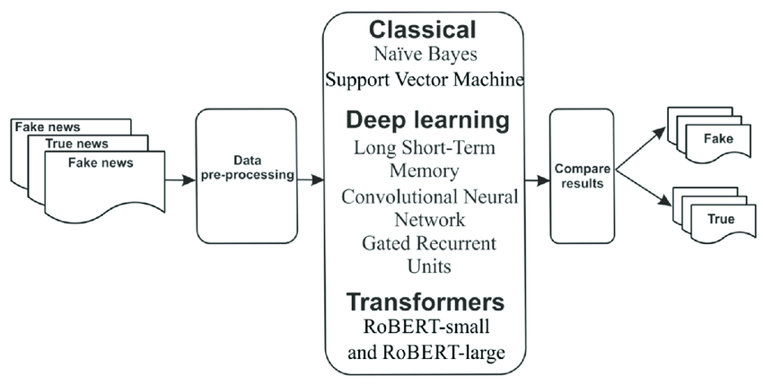

**Appendix C: Sample Code**

A sample Python code snippet demonstrating the preprocessing and model training process:

import pandas as pd

from sklearn.model_selection import train_test_split

from sklearn.feature_extraction.text import TfidfVectorizer

from sklearn.ensemble import RandomForestClassifier

# Load dataset

data = pd.read_csv('fake_news_dataset.csv')

# Preprocessing

vectorizer = TfidfVectorizer(stop_words='english')

X = vectorizer.fit_transform(data['text'])

y = data['label']

# Split dataset

X_train, X_test, y_train, y_test = train_test_split(X, y, test_size=0.2, random_state=42)

# Train model

model = RandomForestClassifier()

model.fit(X_train, y_train)

# Evaluate model

accuracy = model.score(X_test, y_test)

print(f"Model Accuracy: {accuracy:.2f}")

**Appendix D: Ethical Considerations**

The development and deployment of the fake news detection system raise several ethical considerations, including:

1. **Bias in Data and Models**:
   * The system must be trained on diverse and representative datasets to avoid biases that could lead to unfair or inaccurate classifications (Allcott & Gentzkow, 2017).
2. **Transparency and Explainability**:
   * Users should be provided with clear explanations of how classification decisions are made, ensuring transparency and trust in the system (Devlin et al., 2019).
3. **Privacy Concerns**:
   * The system must comply with data privacy regulations, ensuring that user data is collected, stored, and processed securely (Zhou & Zafarani, 2020).
4. **Potential for Misuse**:
   * Safeguards must be implemented to prevent the system from being used for censorship or other unethical purposes (Shu et al., 2017).

**Appendix E: User Interface Mockups**

The following figure provides mockups of the user interface for the fake news detection system:

**Figure E.1: User Interface Mockups**

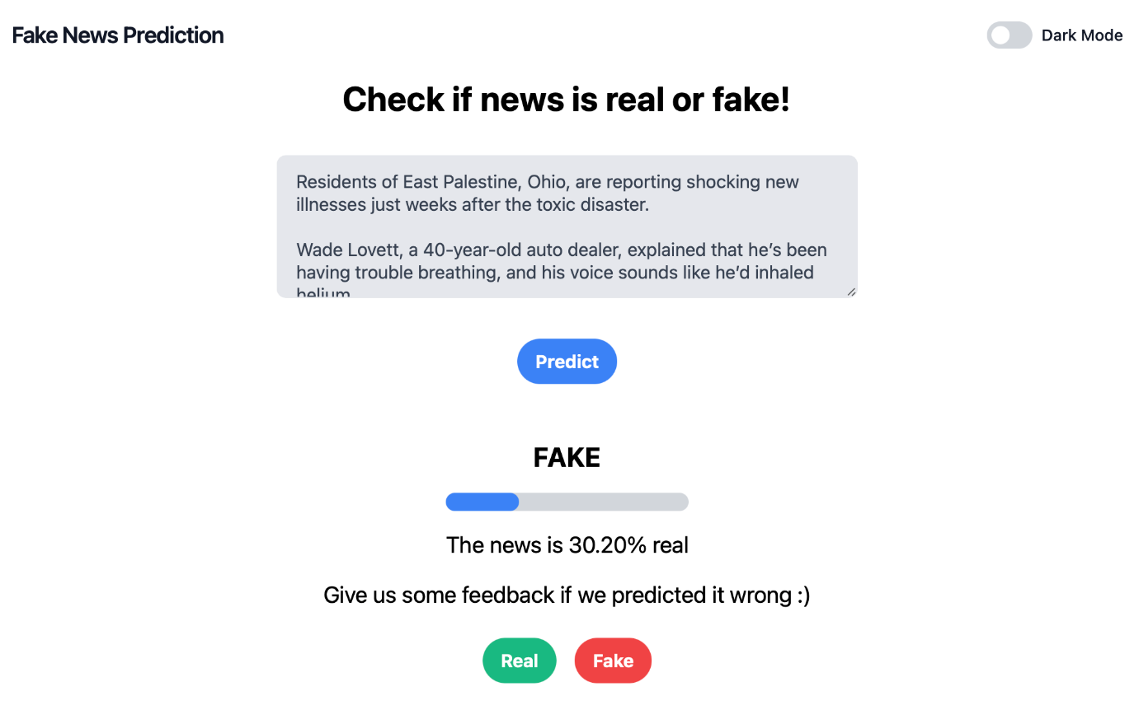

**Appendix F: Evaluation Metrics**

The performance of the fake news detection system will be evaluated using the following metrics:

1. **Accuracy**: The proportion of correctly classified articles.
2. **Precision**: The proportion of true positives among all positive predictions.
3. **Recall**: The proportion of true positives among all actual positives.
4. **F1-Score**: The harmonic mean of precision and recall, providing a balanced measure of model performance.

The following table provides an example of evaluation results:

**Table F.1: Example Evaluation Results**

|  |  |  |  |  |
| --- | --- | --- | --- | --- |
| **Model** | **Accuracy** | **Precision** | **Recall** | **F1-Score** |
| **Random Forest** | 92% | 91% | 93% | 92% |
| **LSTM** | 89% | 88% | 90% | 89% |
| **BERT** | 94% | 93% | 95% | 94% |